choose your adventure

Standard Partner Visit
7 Days Total
- 4 Days at the CarePoint – Engage with the community, build relationships, and witness transformation firsthand.
- 3 Travel & Transition Days – Designed to give you the necessary time to travel, rest, and adjust for a meaningful experience.

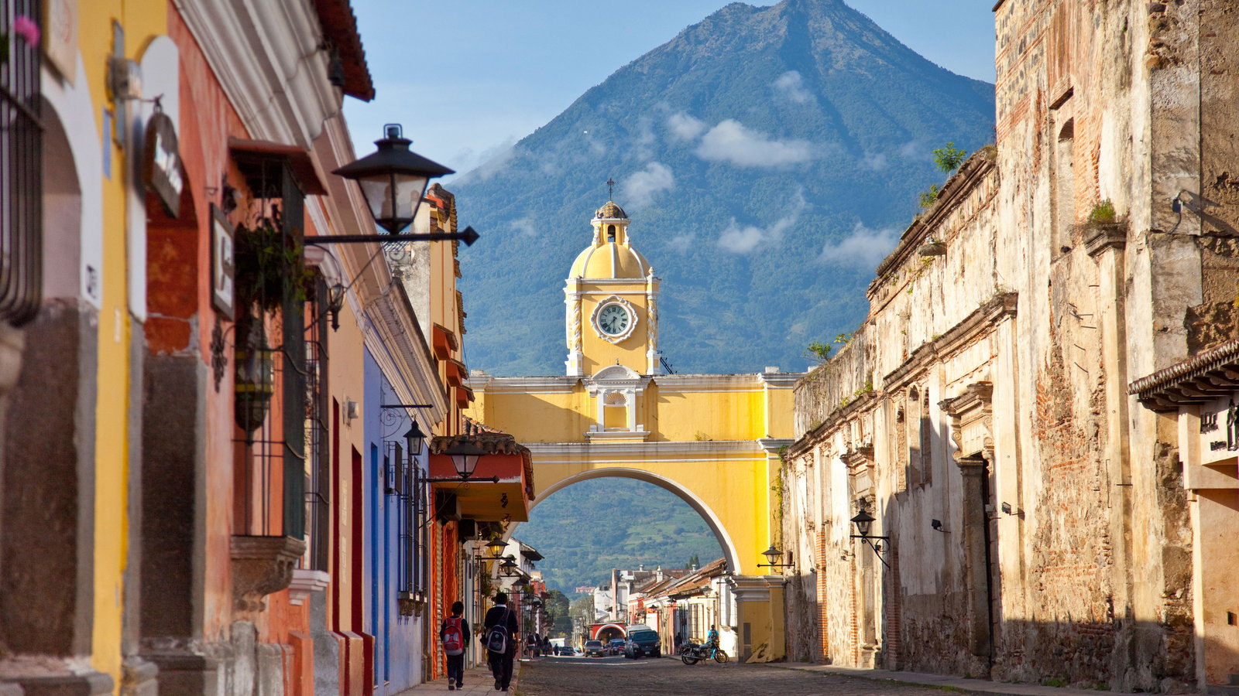

Extended Partner Visit
9 Days Total
- 4 Days at the CarePoint – Engage with the community, build relationships, and witness transformation firsthand.
- 3 Travel & Transition Days – Designed to give you the necessary time to travel, rest, and adjust for a meaningful experience.
- 2 Cultural Excursion Days – Experience Guatemala’s beauty, history, and landscape in a deeper way before heading home.

ArrIVE IN GuAtemala — WE’re SO GLAD YOU’re HERE!
​ Take in the views as we venture to your lodging for the week.
CarePoint Day One — Welcome!
​ Grand welcome, home visits, and a walk around the community.

CarePoint Day Two — Sponsorship Day!
​ The visiting team and host community connect sponsors with their
prayer partners and meet those still waiting.
Goal: every friend partnered by the end of the visit!

CarePoint Day three — two way transformation
​ Today is shared leadership: the visiting team leads the first half with a. activities like Bible study, baking, drama, and sports; then the host co. community leads the second half.

CarePoint day FOUR — FAREWELL
​ Morning: connect with CHC CarePoint staff through listening and
encouragement—pour into those who pour out daily.
Evening: enjoy a cultural experience of your choice.

Cultural Day — Explore the beauty that is Guatemala!
​ Tour Guatemala City, walk around and experience Antigua or spend a da spend the day at a beach!
Departure Day — Time to go home with full hearts

base ITINERARY

Day
1
Day
2
Day
3
Day
4
Day
5
Day
6
Day
7
*This is a sample itinerary for a 7-day Partner Visit to Guatemala. Actual itineraries are based on your partner community, goals of the visit, and team preferences.

